LEAKSENSE

Smart Water Leak Detection System: Integration Strategy and Architecture
Integration Strategy
- Sensor Fusion Algorithms: Utilize techniques such as Kalman filters and Bayesian networks to combine sensor readings for improved reliability.
- Confidence Scoring: Assign confidence scores to each sensor’s input to prioritize alerts and reduce false positives.
1.Edge + Cloud Architecture
Edge Computing Layer
Devices:
- ESP32
- Raspberry Pi
- FPGA (for mission-critical zones)
Functions:
- Local signal processing
- Real-time anomaly detection
- Temporary data buffering
Benefits:
- Reduces cloud load
- Enables instant alerts
- Saves bandwidth and energy
2.Communication Layer
Protocols:
- LoRaWAN or NB-IoT (LPWAN)
Rationale:
- Long-range, low-power communication
- Ideal for distributed residential setups
Fallback:
- Wi-Fi for high-bandwidth zones
3. Data Transmission Strategy
Protocols:
- MQTT or CoAP for lightweight messaging
Method:
- Transmit only anomalies or compressed summaries
- Batch data from multiple homes before sending to municipalities
3.Cloud Storage & Analytics Layer
Platforms:
- AWS IoT
- Azure IoT Hub
- Google Cloud IoT Core
Functions:
- Long-term data storage
- Machine learning-based pattern recognition
- Dashboard for users and municipalities
Security:
- TLS encryption
- Role-based access control
4.Modular Sensor Design
Plug-and-Play Kits:
- Pressure sensor module
- Acoustic sensor module
- Moisture sensor module
Benefits:
- Easy installation
- Scalable upgrades
- Targeted deployment based on building layout
5.Deployment Blueprint
Home Level
- Edge device with all three sensors
- LoRaWAN/NB-IoT module
- Local alert system (mobile app, buzzer)
Neighborhood Hub
- Aggregator node for batch transmission
- Optional edge analytics for group-level insights
Municipal Dashboard
- Leak heatmaps
- Predictive maintenance alerts
- Water loss analytics
Why This Works
- Accuracy: Sensor fusion reduces false positives
- Efficiency: Edge computing and LPWAN minimize costs
- Scalability: Modular design supports phased rollout
Use InfluxDB at the edge or home level:
- Lightweight
- Fast ingestion
- Easy to deploy on ESP32 or Raspberry Pi
- Store short-term data and transmit summaries
- Use TimescaleDB at the municipal or cloud level:
- Supports complex analytics
- Scales with PostgreSQL tools
- Ideal for dashboards, reporting, and ML integration
Can upscale with-
- Edge Device: InfluxDB stores local data, triggers alerts
Cloud Backend: TimescaleDB aggregates data from multiple homes, supports city-wide analytics
Sensor Integration:
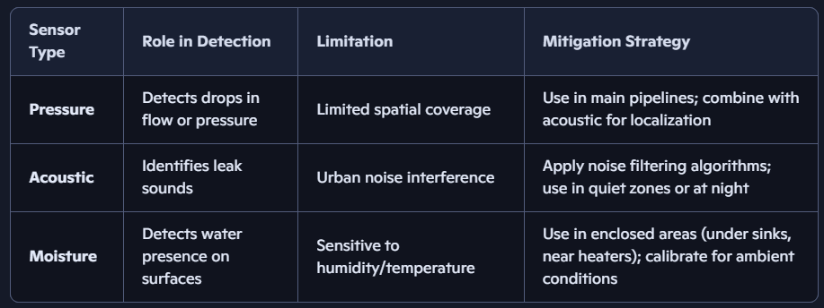
Final outline:
